Purchase Order number:
Name of company/organisation:
Contact name:
Daytime Tel. No:  Mobile No:  Fax No:  Email Address: |  |  | Invoice Address:
Date Required | Start/End Time | Number of Attendees | Room Required | Meeting/Course Title
Room Setup  Delete where applicable *  Layout:  See guidance notes below  Boardroom  Theatre  Classroom  Cabaret  U- Shape  Equipment:  Flipchart Pad & Pens  OHP & Screen  LCD Projector  Laptop  DVD/Video  Microphone  Video Conferencing  Skype |  | Refreshments - Tea/Coffee/Water  (N. B. One serving is included per session in the room rate. Additional servings are charged at £1.50 per person)  Please insert time/s required:  On arrival: Mid-morning:  Lunch time: Mid-afternoon:  Catering (separate charges apply)  Number of lunches required:  Time required:  Buffet choice:  Delete where applicable *  Sandwich Platter (£4.95 p.p.) Platter A (£6.95 p.p.)  Platter B (£7.50 p.p.)  Optional Extras:  Delete where applicable *  Fresh Cream Cakes (£1.85 p.p.) Assorted Mini Cakes (£1.40 p.p.)  Fruit Platter (£2.25 p.p.)  Special dietary requirements:
Other relevant information:

I/We confirm that we have read the terms and conditions of hire and agree on behalf of the organisation to comply with the conditions and be bound by them.

Signature of applicant: ……………………………………………………

Date: …………………………………………..
Please email: clare.sutherland@wrestparkenterprise.co.uk or fax this form to: 01525 864351
Capability House, 31 Wrest Park, Silsoe, Bedfordshire MK45 4HR Tel: 01525 864350
www.wrestparkenterprise.co.uk
Booking Form from September 2016
Room Layout | Conference Room | Board Room | Training Room | Meeting Room
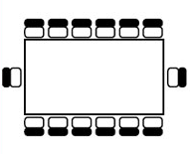  Boardroom | 22 Delegates | 13 Delegates | 18 Delegates | 8 Delegates
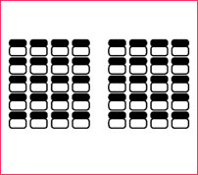  Theatre | 60 Delegates | N/A | 30 Delegates | N/A
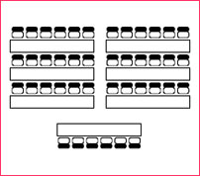  Classroom | 24 Delegates  (2 delegates per table ) | N/A | 18 Delegates | N/A
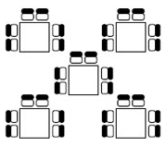  Cabaret | 30 Delegates | N/A | 24 Delegates | N/A
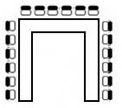  U shape | 25 Delegates  (30 delegates closed square) | N/A | 22 Delegates | N/A

*Half-day (Monday – Friday): 9am - 1pm / 1pm - 5pm.

N.B. Please note that bookings which do not fall within day/half-days, or run over agreed times will be liable to a surcharge.

**WPE tenants qualify for a 25% discount on the above prices
One serving of tea/coffee/water is included per half-day in the room rate. Each additional serving is charged at £1.50 per head plus VAT.

 | Capability House |  | Endeavour House | Enterprise  House
 | Conference Room  (25–60 delegates) | Boardroom  (12 delegates) | Training Room  (18-24 delegates) | Meeting Room  (up to 8 delegates)
Room price per half-day* (Exclusive of VAT) | £210 | £130 | £175 | £100
Room price per day (Exclusive of VAT) | £370 | £230 | £340 | £180
Room price per hour (Subject to availability, exclusive of VAT) | N/A | £34 | £44 | £30

Additional Equipment
Room prices include the supply of flipchart and pens, OHP and screen. Please list any additional equipment required on your booking form. The WEC team are happy to provide you with any assistance you may need in setting up and positioning equipment. Please note that all equipment is subject to availability.

Video and audio conferencing are charged separately – please ask for details.

Catering Options
Sandwich Platter at £4.95 per person

Selection of Sandwiches, Fruit Juice and Assorted Mini Cakes

Platter A at £6.95 per person

Selection of Sandwiches, Sausage Rolls, Chicken Tikka Sticks, Mini Margherita Pizzas (v), Tortilla Chips & Dips
And Fruit Juice

Platter B at £7.50 per person

Selection of Sandwiches and Wraps, Onion Bhaji (v), Vegetables Spring Rolls (v), Chicken Satay Fillets,
Tortilla Chips & Dips and Fruit Juice

Optional Extras

Fresh Cream Cakes £1.85 per person Assorted Mini Cakes at £1.40 per person

Fruit Platter at £2.25 per person

Our caterers will make every effort to provide alternatives for special diets but cannot guarantee that ingredients do not contain, or have not been contaminated by certain allergens. We will not assume any liability for adverse reactions to food consumed.

Guidance Notes for Visitors to the Wrest Park Enterprise Campus

Car Parking
Please ensure that all cars have been parked correctly in the Visitor Car Park in front of Capability House.

On Your Arrival
The hirer or the facilitator must report to reception on their arrival. In each room you will find a register; each person must sign in.

Security and Fire Instructions
The hirer or their representative is responsible for ensuring that the Fire and Health and Safety requirements are complied with. They are responsible for ensuring that the attendance register is correctly completed, for notifying delegates of Fire and Health and Safety requirements and for ensuring evacuation of delegates should the fire alarm activate.

Please be aware of the following emergency instructions. Anyone with a disability who may encounter special difficulties should inform the event organiser when signing the attendance register. In the event of a fire, the fire alarm will sound continuously. Please use the nearest safe emergency exit. Assemble at the fire assembly point in front of Capability House, Endeavour House or Enterprise House, as appropriate. Do not stop to collect personal belongings. Do not re-enter the building until authorised to do so by a Fire Officer or Fire Warden.

No Smoking Areas
All buildings on the WPE campus are ‘No Smoking’ buildings. Those who smoke should do so well away from the building. Smoking bins are provided.

Mobile Phones and Public Telephone
If you wish to make a telephone call during your visit to the WPE campus please confine all mobile phone use to the reception areas or outside the buildings.

Queries or Problems
If you have any queries or problems, please ask a member of staff. We are always pleased to improve our services and will take your views fully into account.

Unloading
If you have items to unload, please go to reception for admittance.

Terms & Conditions of Business

Prices
All prices quoted are subject to VAT at the standard rate. Prices are reviewed annually on the 1st September. All bookings after this date will be charged at the new rate.

Bookings
All provisional bookings must be confirmed by completion of a booking form within 14 days. If no booking form is received WPE reserve the right to re-sell the facility.

Any equipment required for the booking must be ordered in advance to ensure availability. Final numbers must be confirmed not less than 7 days prior to the event. Special dietary requirements should also be advised at this time. Regretfully, numbers confirmed at this time must be paid for even if subsequently cancelled.

All catering and refreshments will be supplied by WPE, unless otherwise agreed.

Surcharge
The Management Team reserves the right to charge a sum equal to 2 hours for bookings which do not fall within the day/half-day session times of 9am - 1pm / 1pm - 5pm (Monday – Friday).

Management also reserves the right to charge a sum equal to the hourly rate for the room in use where a meeting overruns the agreed time. The minimum surcharge will be equal to 1 hour irrespective. Please note that the conference room is charged at £65.00 per hour.

Payment
All invoices are due for payment within 30 days of the invoice date.

Payment will be in the form of a card payment, direct debit or by BACs.

Cancellation by the client
Any cancellation must be in writing. This applies to all events that have been confirmed.

In the event of a cancellation the following scale of charges will apply:

Less than 48 hours before the event 100%
Less than 1 week before the event 50%
Less than 2 weeks before the event 15%

Changes/Cancellation by WPE
The management reserves the right to re assign a booking to an alternative room.

WPE reserves the right to move the client to a different room if the numbers using the room exceed the number booked and to charge for the larger room.

In the event that WPE is unable to fulfil the booking for a client due to forces beyond their control, WPE will work with the client to source an alternative venue.

WPE reserves the right to cancel any booking due to poor behaviour on the part of any client, delegate or guest. In this case WPE will not be liable for the payment of any compensation to the hirer or any other person.

In the event of the occurrence of a force majeure the obligations of WPE will be suspended.

Parking
WPE does not accept any responsibility for vehicles using the car park.

WPE does encourage all users of the centres to car share or to use public transport where possible. Whilst there is a large car park at WEC we cannot guarantee a car parking space.

Health and Safety
WPE has public liability insurance.

WPE does not accept responsibility for loss or damage to property or vehicles of any client, delegate or visitor to the Wrest Park Enterprise Campus.

The health and safety of all visitors to WPE is of paramount importance and as such we ask that all clients, delegates and guests comply with Health and Safety legislation and other licensing and appropriate statutory regulations.

Data Protection
We regard the lawful and correct treatment of personal information as very important to successful operation for maintaining confidence between ourselves and those with whom we deal, therefore we make every effort to ensure that personal data is treated lawfully and correctly by any employee that has access to personal information. We fully endorse and adhere to the principles of data protection as detailed in the data protection act 1998. Any information supplied will not be passed on to third parties.

Location and Parking

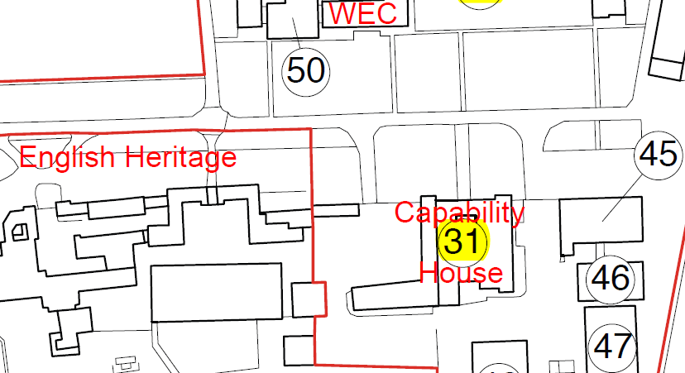

Visitor Parking
Park Avenue
52

Visitor overflow Parking
Endeavour House
50

Capability House is located in Wrest Park, Silsoe, close to the English Heritage Mansion House and Grounds. To find us, follow the brown English Heritage signs which will lead you down a long tree-lined avenue. Keep going past the Mansion House, and Capability House is a little further on, on the right-hand side of the avenue. The visitor parking area for all 3 buildings is in front of Capability House.

